**Problem Statement & Objective**

Zomato operates in a competitive food delivery market where **sales growth depends on customer satisfaction, delivery speed, and restaurant performance**. The company needs to identify which factors most influence sales, improve operational efficiency, and understand customer behaviour to stay ahead.

The objective of this project is to use **SQL-based data analysis** on Zomato’s datasets — covering customers, orders, restaurants, and deliveries — to:

1. Measure key KPIs like delivery efficiency, restaurant performance, and customer loyalty.
2. Identify trends and problem areas affecting revenue.
3. Provide **actionable insights** to improve service quality, optimize marketing, and increase sales.

This analysis aims to guide **data-driven decisions** that enhance customer experience and strengthen Zomato’s market position.

**EER DIAGRAM**

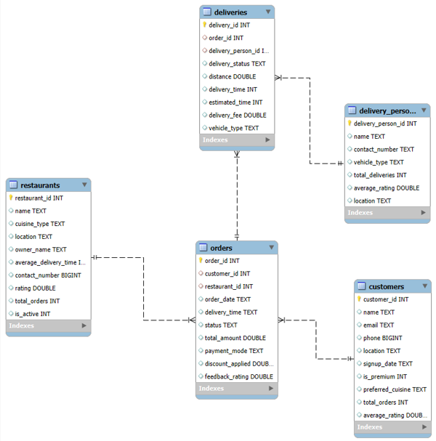

**1. Total Sales Revenue**

SELECT ROUND(SUM(total_amount)/1000000, 2) AS total_sales_in_Millons

FROM orders

WHERE status = 'Delivered';

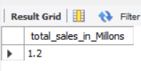

**Insight:** This KPI shows the total revenue from all delivered orders. A healthy upward trend means strong sales performance.  
**Recommendation:** Use this as your **primary sales target metric**. If growth slows, introduce **seasonal discounts or influencer marketing** to boost demand

**2. Monthly Sales Trend**

SELECT DATE_FORMAT(STR_TO_DATE(order_date, '%d-%m-%Y %H:%i'), '%Y-%m') AS month,

ROUND(SUM(total_amount), 2) AS total_sales

FROM orders

WHERE status = 'Delivered'

GROUP BY month

ORDER BY month;

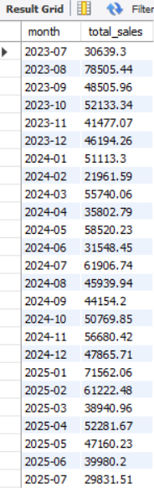

**Insight:** Monthly data reveals sales peaks (e.g., festive seasons) and slow months.  
**Recommendation:** For low-sales months, plan **special campaigns**, tie-ups with brands, or introduce **limited-time offers** to stimulate demand.

**3. Top 10 Restaurants by Sales**

SELECT r.name, ROUND(SUM(o.total_amount), 2) AS total_sales

FROM orders o

JOIN restaurants r ON o.restaurant_id = r.restaurant_id

WHERE o.status = 'Delivered'

GROUP BY r.name

ORDER BY total_sales DESC

LIMIT 10;

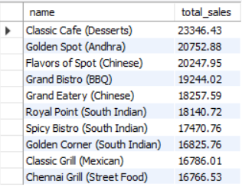

**Insight:** These restaurants are your **highest revenue drivers**.  
**Recommendation:** Strengthen partnerships — offer them **priority delivery slots**, **exclusive banners on the app**, and **premium placement** in search results.

**4. Top Selling Cuisine Types**

SELECT r.cuisine_type, COUNT(o.order_id) AS total_orders, ROUND(SUM(o.total_amount), 2) AS total_sales

FROM orders o

JOIN restaurants r ON o.restaurant_id = r.restaurant_id

WHERE o.status = 'Delivered'

GROUP BY r.cuisine_type

ORDER BY total_sales DESC;

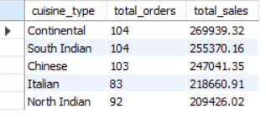

**Insight:** Popular cuisines have high demand and can drive repeat orders.  
**Recommendation:** Encourage restaurants of top cuisines to **bundle meals**, **add combo offers**, or **cross-promote with beverages/desserts**.

**5.Repeat Customer Rate**

SELECT ROUND(

COUNT(DISTINCT customer_id) / (SELECT COUNT(*) FROM customers) * 100, 2

) AS repeat_customer_percentage

FROM orders

WHERE customer_id IN (

SELECT customer_id FROM orders GROUP BY customer_id HAVING COUNT(order_id) > 1

**);**



**Insight:** Loyal customers are more profitable than new customers.  
**Recommendation:** Introduce loyalty points, personalized offers, and birthday discounts to maintain and grow this rate.

**6. Average Order Value (AOV)**

SELECT ROUND(AVG(total_amount), 2) AS average_order_value

FROM orders

WHERE status = 'Delivered';



**Insight:** Higher AOV means customers spend more per order.  
**Recommendation:** Promote add-ons like drinks/desserts, suggest family packs, and use AI-based recommendations during checkout.

**7. Customer Lifetime Value (CLV)**

SELECT c.customer_id, c.name, ROUND(SUM(o.total_amount), 2) AS lifetime_value

FROM customers c

JOIN orders o ON c.customer_id = o.customer_id

WHERE o.status = 'Delivered'

GROUP BY c.customer_id, c.name

ORDER BY lifetime_value DESC

LIMIT 15;

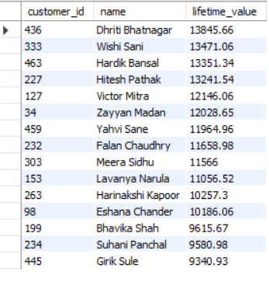

**Insight:** High CLV customers contribute disproportionately to revenue.  
**Recommendation:** Create a **VIP program** with perks like free delivery, early access to discounts, or dedicated support.

**8. Delivery Speed Impact on Ratings**

SELECT delivery_status,

ROUND(AVG(feedback_rating), 2) AS avg_rating

FROM (

SELECT

CASE

WHEN d.delivery_time <= d.estimated_time THEN 'On Time'

ELSE 'Late'

END AS delivery_status,

o.feedback_rating

FROM deliveries d

JOIN orders o

ON d.order_id = o.order_id

) AS sub

GROUP BY delivery_status;

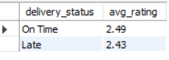

**Insight:** Faster deliveries lead to better ratings → better customer retention.  
**Recommendation:** Invest in **optimizing delivery routes**, incentivize **on-time delivery**, and **expand rider fleet** in high-demand zones.

**9. Restaurants with Low Ratings but High Orders**

SELECT r.name, r.rating, COUNT(o.order_id) AS total_orders

FROM restaurants r

JOIN orders o ON r.restaurant_id = o.restaurant_id

GROUP BY r.name, r.rating

HAVING r.rating < 2 AND total_orders >11;

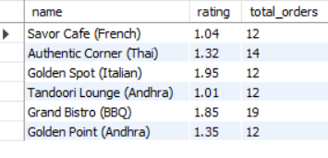

**Insight:** These are **high-demand but quality-risk restaurants**.  
**Recommendation:** Work with them to **improve food quality**, **reduce delays**, and **address customer complaints** before customers churn.

**10. Most Profitable Payment Method**

SELECT payment_mode, COUNT(*) AS order_count, ROUND(SUM(total_amount), 2) AS total_sales

FROM orders

WHERE status = 'Delivered'

GROUP BY payment_mode

ORDER BY total_sales DESC;

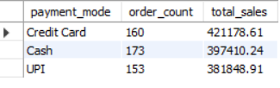

**Insight:** Some payment modes may have lower transaction fees and higher conversion rates.  
**Recommendation:** Promote low-cost/high-convenience payment modes with **cashback offers** to reduce payment gateway costs and boost sales.

**11. Cancellation Reasons Analysis**

SELECT status, COUNT(*) AS total_orders

FROM orders

GROUP BY status

ORDER BY total_orders DESC;

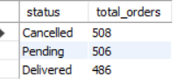

**Insight:** High cancellations cause revenue loss and poor customer experience.  
**Recommendation:** Identify **frequent causes** (long delivery time, item unavailable) and **automate early order status alerts** to customers.

**12. Average Delivery Distance**

SELECT ROUND(AVG(distance), 2) AS avg_distance_km

FROM deliveries

WHERE delivery_status = 'Delivered';



**Insight:** Longer distances increase delivery costs and delay times.  
**Recommendation:** Encourage **hyperlocal deliveries** by showing nearby restaurants first and limiting delivery zones in traffic-heavy areas.

**13. Top Delivery Persons by Revenue Generated**

SELECT dp.name, round(SUM(o.total_amount) ,2)AS total_revenue

FROM deliveries d

JOIN delivery_persons dp ON d.delivery_person_id = dp.delivery_person_id

JOIN orders o ON d.order_id = o.order_id

GROUP BY dp.name

ORDER BY total_revenue DESC

LIMIT 5;

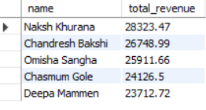

**Insight:** High-performing riders contribute directly to sales volume and customer satisfaction.  
**Recommendation:** Reward top riders with **bonuses**, **priority shifts**, and **public recognition** to retain talent

**14. Time of Day with Most Orders(TOP 12 HOURS)**

SELECT HOUR(STR_TO_DATE(order_date, '%d-%m-%Y %H:%i')) AS hour_of_day,

COUNT(*) AS order_count

FROM orders

GROUP BY hour_of_day

ORDER BY order_count DESC;

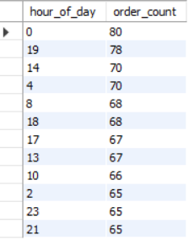

**Insight:** Peak order times are usually lunch (12–3 PM) and dinner (7–10 PM).  
**Recommendation:** Run **time-specific flash sales**, boost **rider availability** in those hours, and ensure **restaurant readiness**.

**15. Premium vs Non-Premium Customer Revenue**

SELECT is_premium, COUNT(*) AS customer_count, ROUND(SUM(o.total_amount), 2) AS total_sales

FROM customers c

JOIN orders o ON c.customer_id = o.customer_id

GROUP BY is_premium;

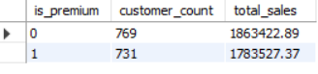

**Insight:** Premium customers generally spend more and order more often.  
**Recommendation:** Promote **premium memberships** aggressively via **free trials**, highlighting benefits like free delivery and exclusive discounts

**16. Orders per Active vs Inactive Restaurant**

SELECT is_active, COUNT(o.order_id) AS total_orders

FROM restaurants r

JOIN orders o ON r.restaurant_id = o.restaurant_id

GROUP BY is_active;

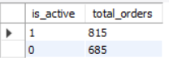

**Insight:** Many inactive restaurants mean lost potential revenue.  
**Recommendation:** Run a **restaurant reactivation campaign** — waive commission for first month, offer marketing support, or simplify onboarding.

**17. Feedback Ratings by Cuisine Type**

SELECT r.cuisine_type, ROUND(AVG(o.feedback_rating), 2) AS avg_feedback

FROM orders o

JOIN restaurants r ON o.restaurant_id = r.restaurant_id

GROUP BY r.cuisine_type

ORDER BY avg_feedback DESC;

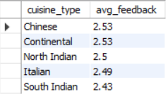

**Insight:** High-rated cuisines can be marketed as “most loved”.  
**Recommendation:** Highlight them on **app banners**, **seasonal promotions**, and use as **USP in ad campaigns**

**18. Delivery Time Efficiency vs Sales**

SELECT

r.name AS restaurant_name,

ROUND(AVG(d.delivery_time), 2) AS avg_delivery_time,

ROUND(SUM(o.total_amount), 2) AS total_sales

FROM deliveries d

JOIN orders o ON d.order_id = o.order_id

JOIN restaurants r ON o.restaurant_id = r.restaurant_id

WHERE o.status = 'Delivered'

GROUP BY r.name

ORDER BY total_sales DESC

LIMIT 20;

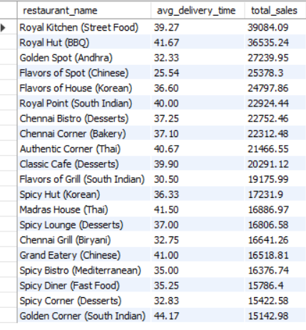

**Insight:** Restaurants with lower average delivery times tend to generate higher total sales, indicating that speed plays a key role in customer satisfaction and repeat orders

**Recommendation:** Work with slow-performing restaurants to optimize food preparation and dispatch processes.